1.

a. Remove “Resume Application” button at top right

b. Remove “Need Help?” button

c. Replace the Lorem Ipsum headline with “A second income just for your LIFE dreams”

d. Remove the line “Guaranteed Income Calculator” and “Buying For Self, Spouse, Child, Grandchild”

e. Form Structure as below

Name Field (First & Last Name)

DOB Field

Annual Income (option to input amount)

Gender

Your Mobile No.

Your Email ID

f. Check Returns button will be replaced as “Submit”

2. This section will stay as it is.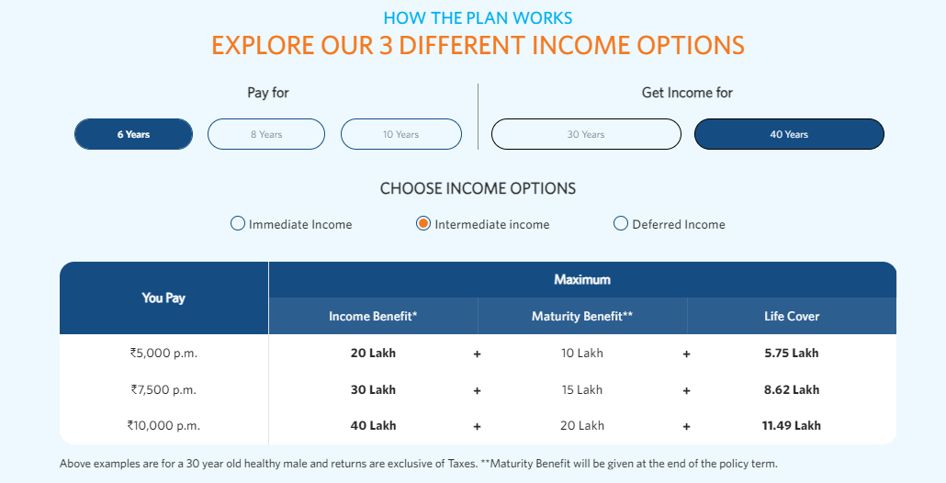

3. This section will be removed

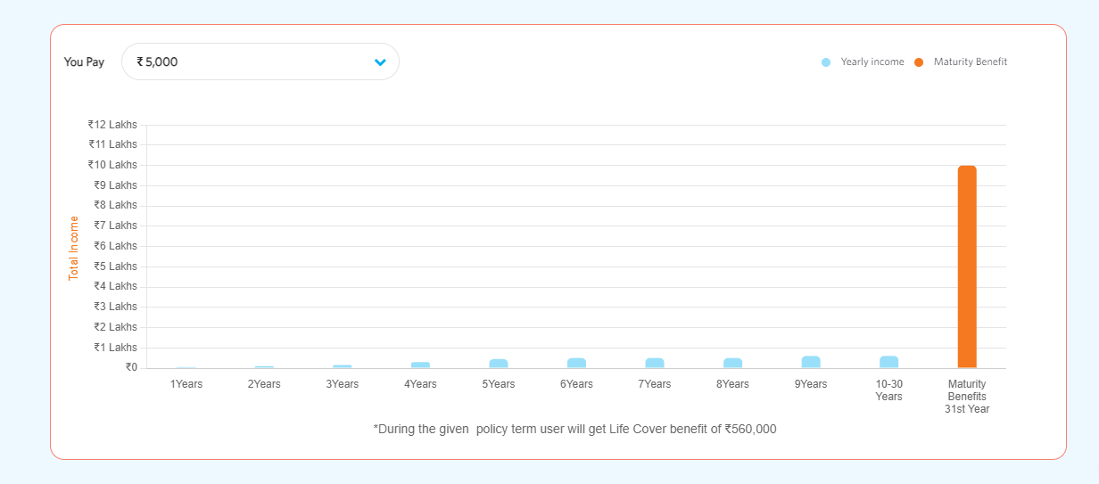

4. All section from “WHAT ARE THE BENEFITS OF BUYING GUARANTEE OF LIFE DREAMS PLAN?”till footer at the bottom will remain same.